Task #03
Name: Dr. Shivangi Sharma
Problem - “How might we reduce the non-teaching workload of school teachers so that they can focus more on meaningful teaching, student engagement, and well-being—without compromising administrative efficiency?”

1️⃣ Empathise – Understanding Teachers’ Reality

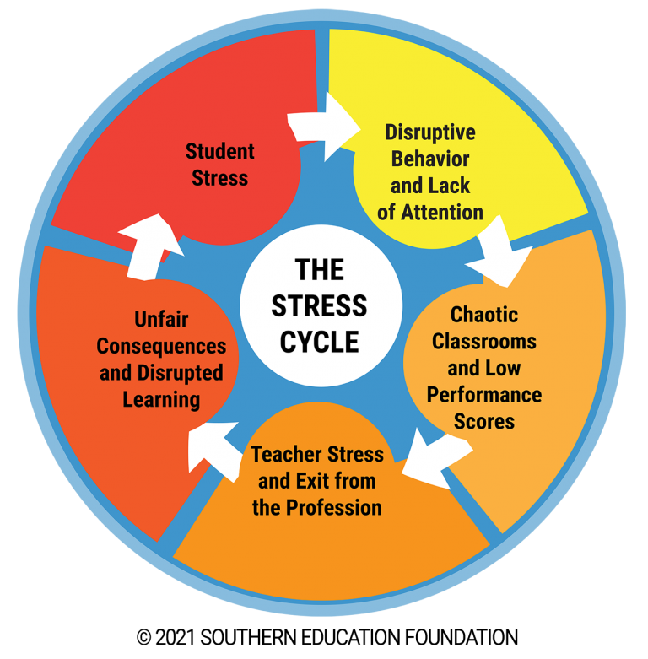

4
Actions:
- Shadow teachers during a school day
- Conduct empathy interviews with teachers across grades
- Observe:
  - Time spent on lesson planning vs admin work
  - Emotional stress points
  - After-school workload
Key questions:
- What tasks exhaust teachers the most?
- Which work feels repetitive or unnecessary?
- How does workload affect classroom energy?

2️⃣ Define – Framing the Core Problem
Refined Problem Statement:
“Teachers are spending excessive time on administrative and repetitive tasks, leading to burnout and reduced classroom effectiveness.”
User Persona Example:
- Ms A, a middle school teacher
- Teaches 6 periods/day
- Handles attendance, reports, uploads, exams, parent communication
Pain Points:
- Lack of time for creativity
- Mental fatigue
- Reduced personal time

3️⃣ Ideate – Generating Solutions



4
Brainstorming prompts:
- How might technology reduce repetition?
- How might students help responsibly?
- How might admin processes be redesigned?
Idea Examples:
- AI-based report writing assistant
- Centralised digital dashboard
- Student tech leaders for simple tasks
- Rotational admin support model
- Voice-to-text tools for teachers
(Quantity over quality at this stage)

4️⃣ Prototype – Building a Low-Cost Solution
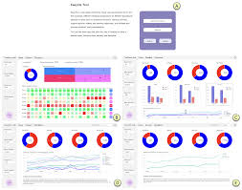

4
Prototype examples:
- Paper mock-up of a Teacher Workload Dashboard
- Google Form automation for reports
- Flowchart showing simplified workflow
- App wireframe (Canva / Figma)
Focus:
- Simple
- Quick
- Easy to modify

5️⃣ Test – Trying It in Real Classrooms
Actions:
- Pilot with 3–5 teachers
- Use for 2 weeks
- Collect feedback:
  - Time saved
  - Ease of use
  - Stress reduction
Feedback tools:
- Reflection journals
- Google Forms
- Group discussion

6️⃣ Iterate – Improving Based on Feedback



4
Improvements might include:
- Fewer clicks
- Regional language support
- Offline features
- Admin integration
Iteration shows real design thinking maturity 💡

7️⃣ Implement / Impact – Long-Term Change
Final Outcome:
- Reduced teacher burnout
- More engaging classrooms
- Better teacher morale
- Improved student learning
Measurable Indicators:
- % reduction in admin hours
- Teacher satisfaction survey
- Classroom engagement levels

